Jacob Graessle]
Incident Response Forensics
Michael Zambotti

lab SEVEN
3/23/2025
Abstract
Lab Seven focuses on learning the basics of Splunk and a scenario that teaches the user how to utilize the abilities of Splunk.

Report

Objective of the Lab
The instructions for Lab Seven were to complete Splunk: Basics and Incident Handing with Splunk on TryHackMe. The user leaned the abilities of Splunk, how to ingest logs, how to navigate logs, using OSINT sites to help with investigations, and how to map an attacker’s steps to the Cyber Kill Chain.

Introduction
The Splunk: Basics room was straightforward in its objectives as the user learned how to use logs on Splunk. Incident Handling with Splunk provided the user with a scenario. The user had to piece evidence together to solve questions related to the tasks.

Process and Analysis:

Splunk: Basics

Task 1: Introduction

Splunk is a top SIEM solution for real-time collection, analysis, and correlation of network and machine logs. This session will cover Splunk's basics, components, log ingestion methods, and log normalization to enhance network visibility and detection speed. No answer is required for this task.

Task 2: Connect with the Lab

Simply connecting the VM. No answer is required.

Task 3: Splunk Components

Splunk has three main components: Forwarder, Indexer, and Search Head.
The Forwarder is a lightweight agent installed on endpoints to collect and send data to Splunk without affecting performance. It collects data from sources like web servers, Windows and Linux machines, and databases.
The Indexer processes the data, normalizes it into field-value pairs, and stores it as events for easy search and analysis.
The Search Head allows users to search indexed logs and visualize results using tools like tables, pie charts, and bar charts.

Which component is used to collect and send data over Splunk?
- Forwarder
- Very simple. Like emails that are forwarded

Task 4: Navigating Splunk

The Splunk home screen includes several sections. The Splunk Bar at the top shows system messages, settings, job progress, help tutorials, and a search feature. You can switch between Splunk apps from here. Below it, the Apps Panel displays the installed apps, with Search & Reporting as the default. The Explore Splunk panel provides quick links to add data, install new apps, and access documentation. Finally, the Home Dashboard shows available dashboards, which can be selected from a dropdown or created and added to the dashboard list. You can also view your custom dashboards in the "Yours" tab.

In the Add Data tab, which option is used to collect data from files and ports?
- Monitor
- Click on app data and scroll down till you see monitor

Task 5: Adding Data

Splunk can ingest any type of data, such as event logs, website logs, and firewall logs. When data is added, it is processed and turned into individual events. Data sources are categorized, and in this room, we'll focus on VPN logs. To upload data, go to the "Add Data" option, select the Upload option, and follow five steps: choose the log source, select the source type, configure input settings (like the index and hostname), review, and finally, complete the upload. Once uploaded, the data is ready for analysis.

Upload the data attached to this task and create an index
"VPN_Logs". How many events are present in the log file?
- 2862
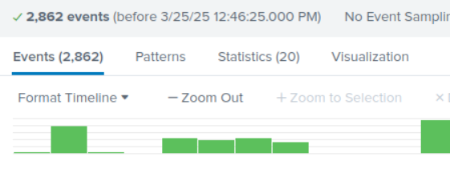
Figure 1.1: Total number of events found in the log file

How many log events by the user Maleena are captured?
- 60
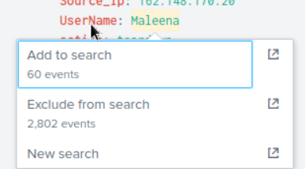
Figure 1.2: Total number of events captured by user “Maleena”

What is the name associated with IP 107.14.182.38?
- Smith
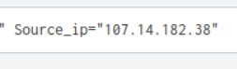
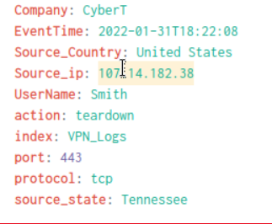
Figure 1.3: IP Address and username associated with it

What is the number of events that originated from all countries except France?
- 2862 - 48 = 2814
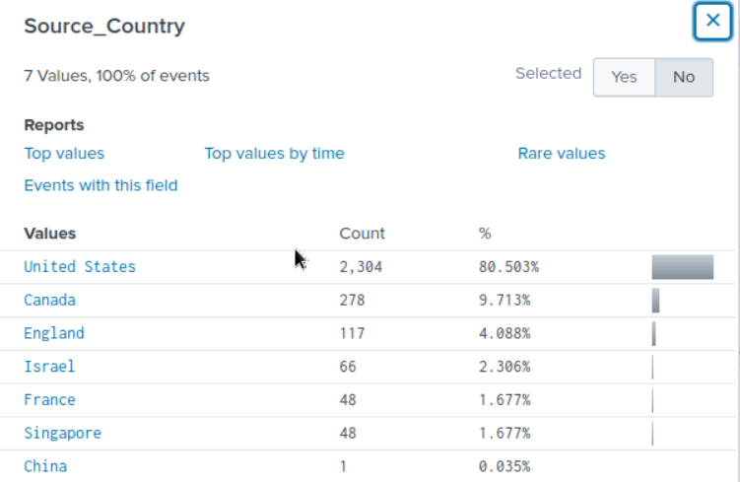
Figure 1.4: Values of logs from different countries

How many VPN Events were observed by the IP 107.3.206.58?
- 14
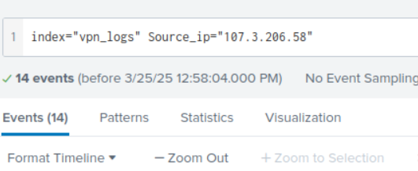
Figure 1.5: Total number of VPN events observed by IP Address 107.3.206.58

Task 6: Conclusion

No answer is required. This is the end of Splunk: Basics.

Incident Handling with Splunk

Task 1: Introduction

Learning objectives for this room are utilizing OSINT sites for investigations, mapping an attacker's activities to the Cyber Kill Chain Phases, using effective Splunk searches to investigate logs, understanding the important of host-centric and network-centric log sources. No answer is needed.

Task 2: Incident Handling Life Cycle

The Incident Handling Life Cycle has four sections: Preparation, Detection and Analysis, Containment, Eradication and Recovery, and Post-Incident Activity/Lessons Learnt. No answer is required for this task.

Task 3: Incident Handling

The task is to investigate a cyber-attack on Wayne Enterprises, where the attackers defaced the company's website. The user will map the attacker's activities through the Cyber Kill Chain model, using Splunk to analyze logs from various sources like web servers, firewalls, and IDS. These logs will help uncover how the attackers entered the network and what actions they took. The investigation focuses on the Cyber Kill Chain, using logs from sources such as Windows Event logs, IIS web server logs, and Suricata IDS alerts.

Task 4: Reconnaissance

The reconnaissance phase involves collecting information about a target, such as a web server, system, or employees. To investigate an attempt against the webserver "imreallynotbatman.com," we start by examining log sources like network traffic. By searching for the domain in log sources such as Suricata, stream:http, fortigate_utm, and IIS, we can find traces of the reconnaissance. After identifying the source IP addresses, we focus on one IP, 40.80.148.42 and examine logs for details like User-Agent and Post requests. Further validation of the scanning attempt is done by analyzing Suricata logs and checking for triggered alerts related to the IP. Visit 10.10.82.201 to access Splunk.

One Suricata alert highlighted the CVE value associated with the attack attempt. What is the value of the CVE?
- CVE-2014-6271
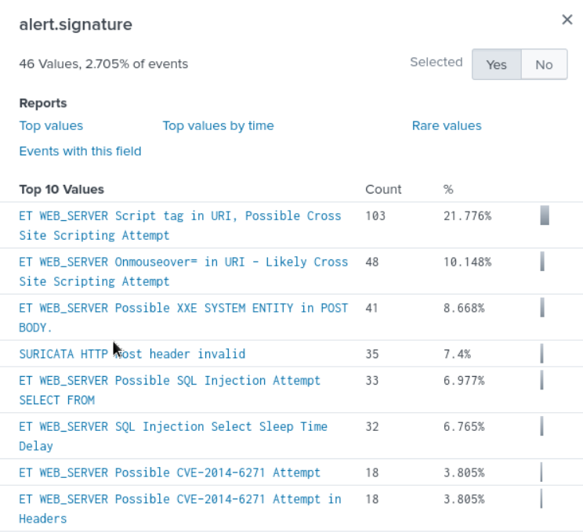
Figure 2.1: CVE value found under “alert signature”

What is the CMS our web server is using?
- Joomla
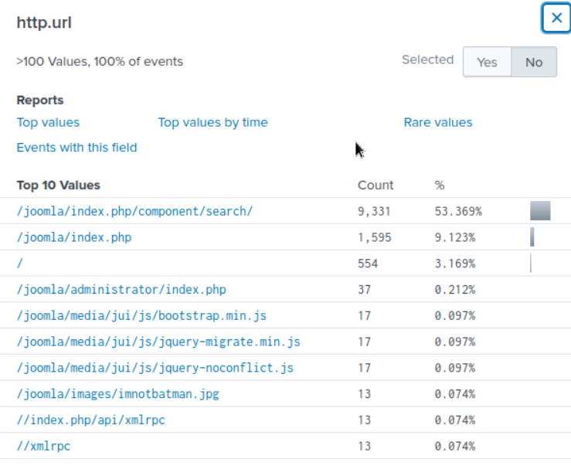
Figure 2.2: CMS found under “http.url” (Joomla)

What is the web scanner, the attacker used to perform the scanning attempts?
- I tried different search queries, and this one ended up working.

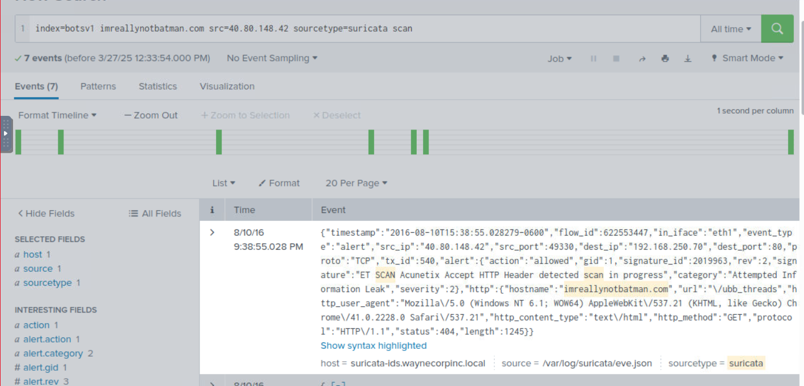
Figure 2.3: Web scanner found within raw data of log (ET SCAN)

What is the IP address of the server imreallynotbatman.com?
- 192.168.250.70
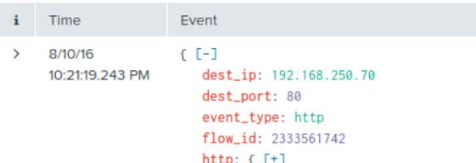
Figure 2.4: Destination IP address of the “imreallynotbatamn.com” website

Task 5: Exploitation Phase

The exploitation phase involves an attacker attempting to exploit vulnerabilities to gain access to a server. In this case, we investigate potential exploitation on the web server "imreallynotbatman.com." From the reconnaissance phase, two IPs were identified, with 40.80.148.42 attempting to scan the server. We analyze HTTP traffic to the server and find multiple POST requests, with one IP, 23.22.63.114, attempting to brute-force the Joomla admin login page. The form_data field reveals repeated attempts with the username "admin" and various passwords, suggesting the use of automated tools. We further refine the search using regex to extract passwords and notice a mix of a Python script and a Mozilla browser in the requests, indicating both automated and manual attempts. The attacker used a brute-force method to try multiple passwords, including one attempt from the IP 40.80.148.42 using a browser.

What was the URL which got multiple brute force attempts?
- /joomla/administrator/index.php
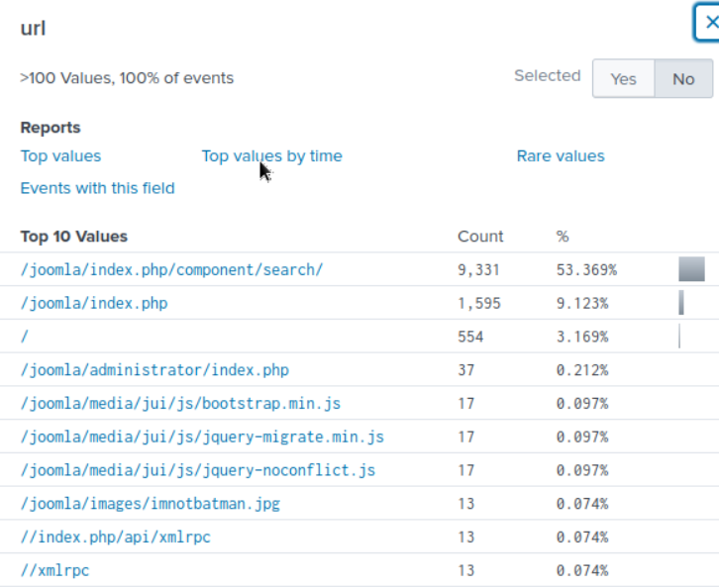
Figure 3.1: Administrator URL that had multiple brute force attempts

Against which username was the brute force attempt made?
- admin - as it was the administrator account

What was the correct password for admin access to the content management system running imreallynotbatman.com?
- batman

How many unique passwords were attempted in the brute force attempt?
- 412
- Seen in the total events

What IP address is likely attempting a brute force password attack against imreallynotbatman.com?
- 23.22.63.114

After finding the correct password, which IP did the attacker use to log in to the admin panel?
- 40.80.148.42

Task 6: Installation Phase

After an attacker exploits a system, they often install a backdoor or malicious application for persistence and control. In this case, the web server iamreallynotbatman.com was compromised through a brute-force attack using a python script. To investigate, we searched for HTTP traffic containing ".exe" on the server IP and found two files, 3791.exe and agent.php, that were uploaded. We then checked if 3791.exe was executed by querying host logs and confirming that it was executed on the server, with traces found in Sysmon, WinEventlog, and Fortigate_utm logs.

Sysmon also collects the Hash value of the processes being created. What is the MD5 HASH of the program 3791.exe?
- AAE3F5A29935E6ABCC2C2754D12A9AF0
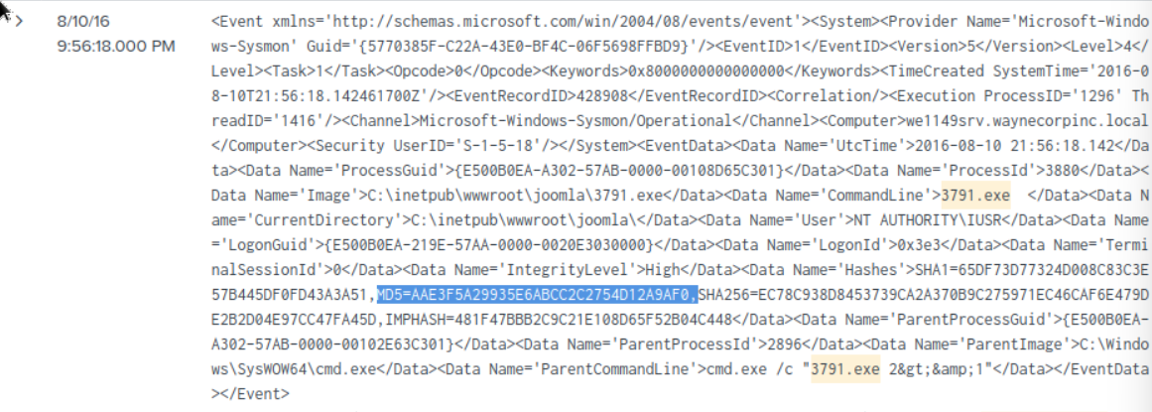
Figure 4.1: MD5 hash found within raw data of log

Looking at the logs, which user executed the program 3791.exe on the server?
- NT AUTHORITY\IUSR
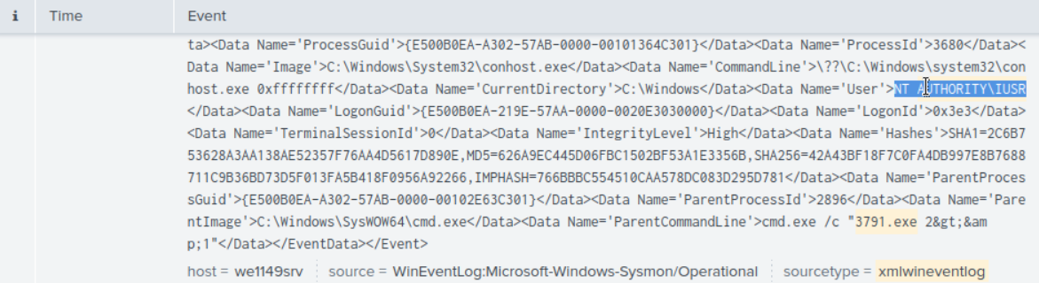
Figure 4.2: User found within raw data of log

Search hash on virus Total. What other name is associated with this file 3791.exe?
- ab.exe
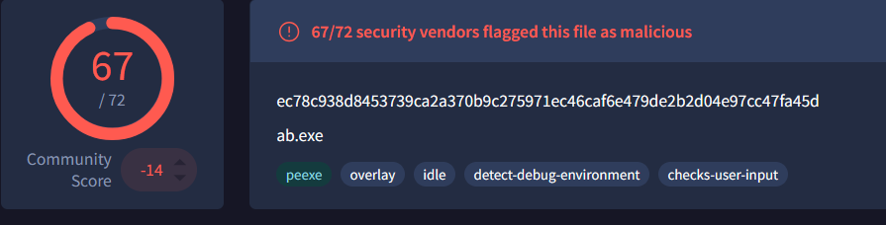
Figure 4.3: Virus name associated with hash value

Task 7: Action on Objectives

The website was defaced following an attack, prompting an investigation into the cause. Analysts began by examining Suricata logs for traffic involving the webserver (192.168.250.70). Initially, no external IPs were found communicating with the server, but reversing the search direction revealed outbound traffic from the server to three external IPs. One of these IPs showed communication involving two PHP files and a suspicious JPEG file named "poisonivy-is-coming-for-you-batman.jpeg." Further analysis traced this file back to the attacker's host, prankglassinebracket.jumpingcrab.com, confirming its role in defacing the site.

What is the name of the file that defaced the imreallynotbatman.com website?
- poisonivy-is-coming-for-you-batman.jpeg

Fortigate Firewall 'fortigate_utm' detected SQL attempt from the attacker's IP 40.80.148.42. What is the name of the rule that was triggered during the SQL Injection attempt?
- HTTP.URI.SQL.Injection
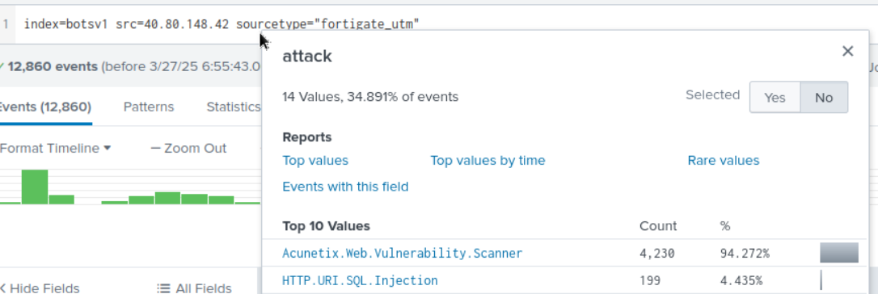
Figure 5.1: Rule that triggered SQL Injection attempt with attacker’s IP

Task 8: Command and Control

The attacker uploaded a file to the server, defaced it, and used Dynamic DNS to resolve a malicious IP. To investigate, firewall logs from Fortinet were analyzed, revealing source and destination IPs and the suspicious domain linked to a Command and Control Server. Additional verification was done using HTTP and DNS logs to confirm the domain's involvement during the infection period.

This attack used dynamic DNS to resolve the malicious IP. What fully qualified domain name (FQDN) is associated with this attack?
- prankglassinebracket.jumpingcrab.com
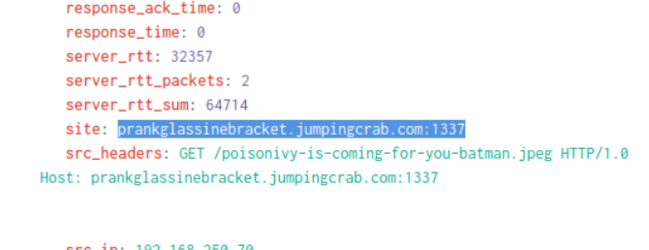
Figure 6.1: Dynamic DNS named associated with the attack

Task 9: Weaponization Phase

The weaponization phase involves adversaries creating malware, establishing deceptive domains, and setting up command-and-control servers for post-exploitation activities. Investigations have identified domains and IPs linked to the attacker, including prankglassinebracket.jumpingcrab.com and IP 23.22.63.114, which are tied to domains resembling Wayne Enterprise. Using OSINT tools like Robtex and VirusTotal, the user aims to gather more intelligence on these domains and IPs, such as associated subdomains or suspicious activity. Whois.domaintools.com can also provide valuable ownership details for further insights.

What IP address has P01s0n1vy tied to domains that are pre-staged to attack Wayne Enterprises?
- 23.22.63.114

Based on the data gathered from this attack and common open-source intelligence sources for domain names, what is the email address that is most likely associated with the P01s0n1vy APT group?
- lillian.rose@po1s0n1vy.com

Task 10: Delivery Phase

Attackers create and deliver malware to gain access or bypass defenses. The user's task is to use available information to track malware linked to a specific adversary group, Poison Ivy, through Threat Hunting platforms and OSINT sites. The group may have backup attack methods. Using sources like ThreatMiner, VirusTotal, and Hybrid-Analysis, we track the suspicious IP (23.22.63.114) and identify a file of interest. Further investigation reveals more details on malware behavior, including network communication, DNS requests, and MITRE ATT&CK mappings.

What is the HASH of the Malware associated with the APT group?
- c99131eO169171935c5ac32615ed6261

What is the name of the Malware associated with the Poison Ivy Infrastructure?
- MirandaTateScreensaver.scr.exe

Task 11: Conclusion

In this exercise, we investigated a cyber-attack on the website "imreallynotbatman.com" of Wayne Enterprise, mapping the attacker’s actions through the 7 phases of the Cyber Kill Chain.

During the Reconnaissance Phase, we discovered the attacker’s IP address (40.80.148.42) scanning the server using Acunetix. In the Exploitation Phase, we found a successful brute-force attack from IP 23.22.63.114, with 142 attempts, one of which gained access.

In the Installation Phase, the attacker uploaded a malicious executable, "3791.exe", to the server. The Action on Objective phase showed that the attacker defaced the website after compromising the server.

During the Weaponization Phase, we identified the attacker’s infrastructure, including the domain "prankglassinebracket.jumpingcrab.com" and email "[Lillian.rose@po1s0n1vy.com]". In the Delivery Phase, we found malware "MirandaTateScreensaver.scr.exe" linked to the attacker’s IP, with MD5 hash c99131e0169171935c5ac32615ed6261, suggesting a secondary attack.

Tools and Resources Used

- Joomla - https://www.joomla.org/administrator/index.php - Joomla was used in the brute force attack to verify the password.
- Robotex - https://www.robtex.com/dns- A platform that provides DNS lookup and network analysis tools to help users investigate domain and IP-related information.lookup/prankglassinebracket.jumpingcrab.com
- Splunk - https://www.splunk.com/
- ThreatMiner - https://www.threatminer.org/host.php?q=23.22.63.114#gsc.tab=0&gsc.q=23.22.63.114&gsc.page=1 - A threat intelligence platform that provides detailed information and analysis on IPs, domains, and other indicators of compromise (IOCs).
- Ubuntu - https://ubuntu.com/ - An open-source, user-friendly operating system based on Linux, designed for desktops, servers, and cloud environments.
- VirusTotal - https://www.virustotal.com/gui/ - A free service that analyzes files, URLs, and other data for potential viruses, malware, and https:
- Whois DomainTools - https://whois.domaintools.com - A service that provides detailed WHOIS data and domain information, including registration details and ownership history.

Challenges Encountered
The main challenge from this lab came from navigating Splunk searches. I was new to the UI, and it took some time to figure out what the basic searches did and how I could use them to help answer questions. I also had trouble accessing Splunk in the VM, but I believe that had to do with my internet connection.

Results and Findings
Both labs provided great foundational knowledge for learning Splunk. I now I have a limited, yet better understanding of how incident responders would use Splunk. Now, I have practice with applying the Cyber Kill Chain to an attacker’s steps as well.

Conclusion
In this lab, as a SOC Analyst, we learned the basics of Splunk, investigated a cyber-attack on Wayne Enterprise's website "imreallynotbatman.com" and mapped it to the 7 phases of the Cyber Kill Chain. We identified reconnaissance activity from IP 40.80.148.42, which used Acunetix to scan the server. Brute-force attacks from IP 23.22.63.114 were successful, allowing the attacker to upload a malicious executable, 3791.exe. The attacker then defaced the website, with the file used identified in the logs. Threat intelligence revealed the attacker’s infrastructure, including masquerading domains and an email address. We also found malware named MirandaTateScreensaver.scr.exe linked to the attacker’s IP.

Future Improvements or Recommendations
I have no recommendations for this lab in the future.

References
Splunk Command Cheat sheet -https://docs.splunk.com/Documentation/Splunk/latest/SearchReference/Listofsearchcommands

